Jack Molesworth

Guided Capstone Project Report

Big Mountain resort has recently installed a chairlift with the intent of increasing the distribution of visitors across the mountain. This new chairlift will increase operating costs of the resort by $1,540,000. Given these additional maintenance costs, Big Mountain Resort needs recommendations on what to do to recoup this money and retain their 9.2% profit margin.

The database manager of Big Mountain Resort has provided us with a CSV file that contains data on different variables that influence company revenue, such as skiable terrain, days open, total chairs, etc. Our goal was to create a model that analyzes how these different variables interact with the “AdultWeekend” variable and make recommendations based on the model’s findings.

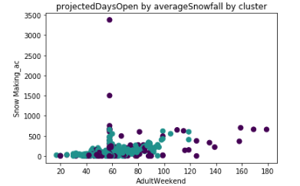

Figure : Adult weekend sales by snow making

Figure 1 shows that there is a positive correlation between adult weekend sales and the amount of snow made. Increasing the total amount of snow made could be beneficial in Big Mountain Resort’s goal to recoup lost profits.

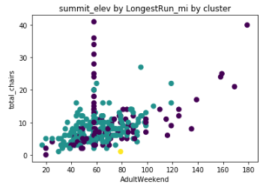

Figure : Adult weekend sales by total chairs

Figure 2 shows that there is a positive correlation between adult weekend sales and the total number of chairs. If eight person seats are installed on the new chairlift instead of two person seats, this could bring in more profits for Big Mountain Resort.